analysis and modeling of lithium flows in porous materials

J. Rudolph*, G. Miloshevsky

School of Nuclear Engineering, Purdue University, West Lafayette, Indiana 47907, USA

*e-mail: jrudolp@purdue.edu

Received December 2, 2017

**Abstract –** The [include 5-7 sentences]

1. INTRODUCTION

Liquid lithium (LL) walls have been identified as a potential solution to many of the engineering problems in a magnetic fusion reactor. The flowing liquid metal could provide heat removal, elimination of erosion via constant renewal of the wall, and possible stabilization of MHD modes. The NSTX-U experiments at the Princeton Plasma Physics Laboratory are planned for testing a pre-filled LL divertor system with capillary wicking channels for supply of lithium from an internal reservoir [ref.]. However, the erosion of the LL surface can be induced by plasma flow or Lorentz forces that may lead to its instability and undesirable effects such as waving, de-wetting, and lithium droplet formation.

2. THEORETICAL AND COMPUTATIONAL MODELS

In this study, both linear stability analysis and computational modeling have been used to study the coupled liquid metal-plasma flows [refs]. The linear stability analysis includes thermal effects, viscous forces, and the porosity of the material through which the LL flows. The expression for the relative velocity of the viscous instability in a porous material is derived. The porous media is described by porosity and permeability coefficients. Using harmonic normal modes in the linearized Navier-Stock equations, we derive the following expression for the relative velocity  of the viscous K-H instability in the porous media

 (1)

where , , ,  denote the velocity and mass density of plasma and melt, , , , , , , ,  are the viscosity and thickness of plasma and melt,  and  are plasma and melt porosities,  and  are permeabilities of plasma and melt in the porous media,  is the wave number associated with small disturbances ,  is the wavelength,  is the frequency,  is the gravity constant,  is the interfacial surface tension,  is the coefficient of heat transfer,  is the latent heat of evaporation,  is the equilibrium heat flux, and  is the heat conduction coefficient. This viscous potential flow analysis was applied to the plasma-lithium melt system shown in Fig. 1. The following parameters are used. [add parameters from slide 7] [I will add these this weekend, as I will need Microsoft Word to format them consistently and I can only use LibreOffice Writer on my office computer]

A computational model is also developed for treating the LL flow with a free surface in a porous material, as well as the coupled LL-plasma flow under the influence of an external magnetic field [refs.]. The model is based on the interFoam solver included in the OpenFOAM CFD toolbox, which uses the volume of fluid (VOF) method to track the LL/gas phases and the interfaces between them. The VOF method supplements the Navier-Stokes equations with a transport equation for the relative volume of LL in each cell, with this “volume fraction” field used to calculate the mean fluid properties in each cell and the surface tension forces at the LL-plasma interface [ref.].

We have expanded the model by implementing the effects of thermal conduction, medium porosity, and magnetic fields into the interFoam solver. The magnetic effects are implemented using the ideal magnetic induction and divergence equations, with the resulting Lorentz (JxB) force and Joule heating terms added to the momentum and heat conduction equations, respectively. The porosity of the medium is implemented as a body force in the momentum equation according to the Darcy-Forchheimer equation, which describes the resistance to flow of the porous medium.

The set-up of the two-dimensional CFD domain is shown in Fig. 2. The domain is divided into three zones: the lower zone as a porous medium saturated by the flowing LL, the middle zone as a nonporous medium containing either argon (Ar) gas or LL flow, and the upper zone as a nonporous medium saturated by the flowing Ar gas. [Should we discuss the dimensions of each region? I’m not clear on whether the thickness of the lower zone is adjusted to match the LL inlet thickness, or kept constant as the LL thickness is varied above/below the zone boundary] Simulations are run in this domain for various LL/gas velocities, melt layer thicknesses, and magnetic field configurations in order to investigate the effect of these parameters on wave formation and splashing.

3. LINEAR STABILITY ANALYSIS

By applying the linear stability analysis to the LL flow, a relationship is obtained for the critical wavelength of interface instability as a function of the relative flow velocity and the porosity/permeability of the porous medium. Stability curves for three different porosity values are plotted in **Figure 3**. In the case of a non-porous medium (infinite porosity, $ε_{m}=1$) it is observed that relative flow velocities greater than 100 m/s induce instabilities in the interface with a critical wavelength approximately 4 cm. However, decreasing the porosity of the medium is shown to have a stabilizing effect on the flow, with greater relative velocities needed to induce instability for all wavelengths. For a porosity of $ε_{m}=0.01$, the flow is predicted to remain stable for relative velocities up to nearly 1 km/s.

The stability condition of the LL surface is then investigated for several permeability values, as shown in **Figure 4**. The stability curve for the case of infinite permeability predicts the development of instabilities with a critical wavelength of approximately 4 cm for relative velocities above 300 m/s, with the reduction of permeability having a stabilizing effect on the flow. For a permeability value of $π_{m}={10}^{-6}$, the instabilities are again suppressed for velocities up to approximately 1 km/s. However, further reduction of the permeability ceases to significantly increase the stability threshold to higher relative velocities as the instabilities become independent of porosity.

4. VOF-MHD MODELING

The VOF-MHD computational model was then used to study the wave development and stability conditions of the LL flow without neglecting the non-linear effects inherent to the system. The simulated formation of waves on the LL surface for various melt layer thicknesses is shown in **Figure 5** for a fixed inlet melt velocity of 2 m/s. A complex dependence is observed between melt layer thickness and the formation of waves, with thin melt layers ($h≤4 mm$) experiencing the formation and growth of long waves ($λ\sim 10-20 mm$), while relatively thick melt layers ($h>10 mm$) exhibit shorth length waves and melt layers of intermediate thickness ($h\sim 6-8 mm$) experience almost no wave formation.

The temporal behavior of the LL as it initially flows into the porous medium was also investigated, as is shown for two flow velocities at several time steps in **Figure 6**. At lower velocities (top 3 rows of the figure, Vm = 1 m/s), the LL smoothly moves into the medium with little disruption. However, doubling the flow velocity (bottom 4 rows of the figure) results in significant disturbance of the LL/plasma interface, as well as partial separation of the flow from the bottom wall as it is driven upwards by the resistance to flow introduced by the porous medium.

Finally, the effect of applying an external magnetic field to the LL melt layer is investigated. As show in **Figure 7**, magnetic fields were applied in the streamwise (x) and vertical (y) directions, with magnitudes between 0.1 and 1 T, which constant melt layer thickness (4mm) and velocity (2 m/s). For the 0.1 T streamwise magnetic field, short-length waves development that were similar to those present in the absence of a magnetic field. The effect of the 0.1 T vertical magnetic field was also subtle, with only long waves of very small amplitude being developed. However, increasing the magnetic field to 1 T resulted in much larger effects for both orientations. Applying a 1 T streamwise magnetic field to the melt layer induced the development of short wavelength ripples in the LL surface and droplet ejection from the peaks. Applying a 1 T upwards magnetic field to the flow resulted in similar surface instability, but with droplet ejection occurring at the early stage of wave development.

5. CONCLUSIONS

The theoretical analysis and computational modeling of the LL surface and the interaction between the plasma and lithium including transition regimes and disruption events are performed. The results provide insights into the understanding of the physical mechanisms of lithium waving, splashing, and droplet formation. [add more]

The results of this research advance the understanding of physical processes that may limit, prevent or eliminate the LL losses from PFCs in fusion devices.

FIGURE CAPTIONS

Fig. 1. Sketch of the plasma-LM system.

Fig. 2. Set up of 2D CFD domain.

Fig. 3. Effects of porosity of medium with very large permeability for LM on stabilization of surface waves.

Fig. 4. Effects of permeability of LM in the medium with porosity εm = 0.1 on stabilization of surface waves.

Fig. 5. Snapshots of LM flow of different thickness with velocity 2 m/s at 1 s.

Fig. 6. Snapshots of 4 mm LM flow with 1 and 2 m/s in porous media at various times.

Fig. 7. Snapshots of Ar plasma flow with various speed over 6 mm LM flowing with 2 m/s.

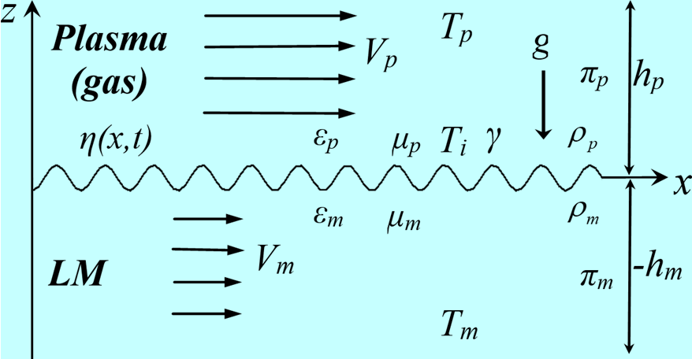

Fig. 1

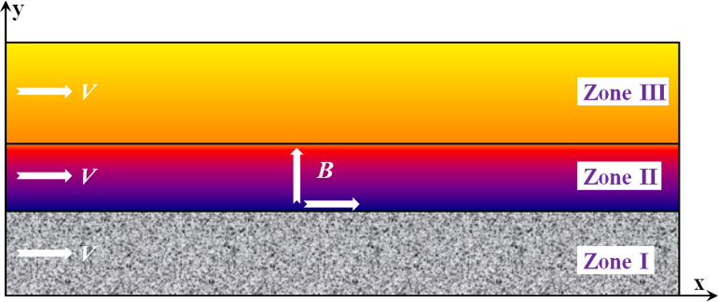

Fig. 2

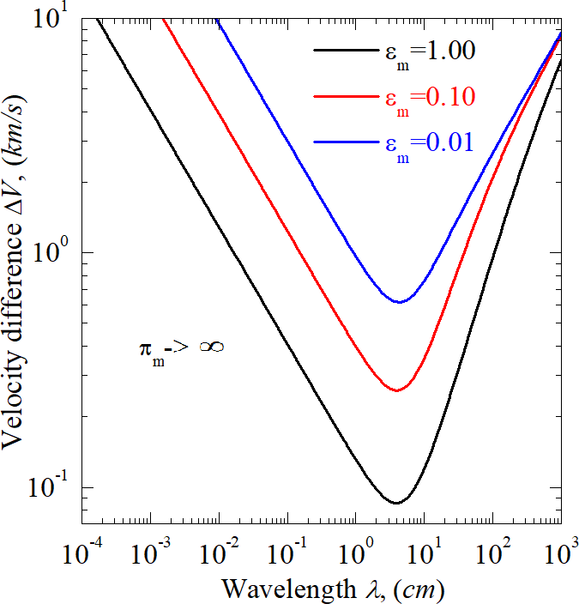

Fig. 3

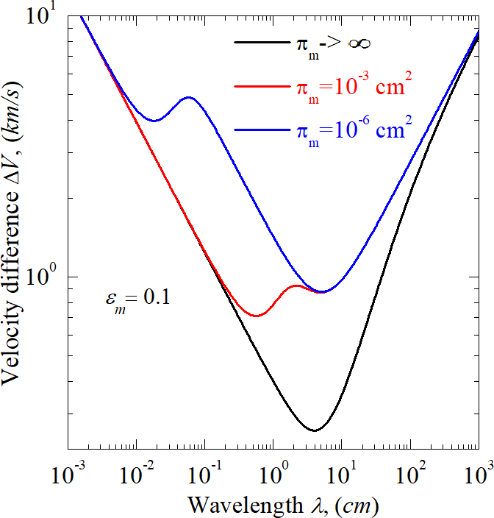

Fig. 4

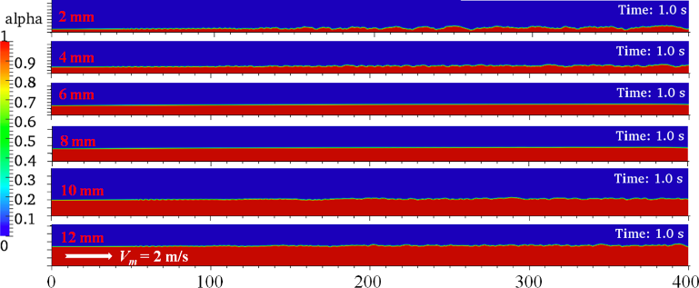

Fig. 5

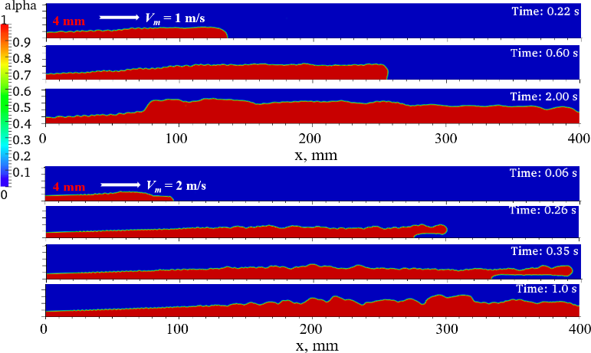

Fig. 6

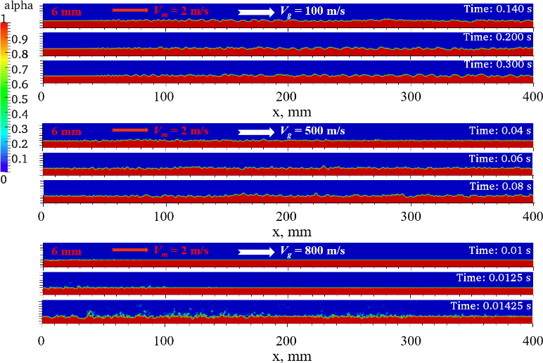

Fig. 7

REFERENCES